EXPERIMENT NUMBER –1.4 _PHOTOELETRIC EFFECT

**Student Name: Shinde Smita Shahaji UID: 20BCS4643**

**Branch: CSE (IOT) Section/Group: IOT (Group-B)**

**Semester: 2nd semester Date of Performance:18/03/2021**

**Subject Name: Quantum and Semiconductor physics lab**

AIM OF THE EXPERIMENT –

To calculate the different frequencies at constant intensity for sodium using photoelectric effect.

APPARATUS-

|  |  |  |
| --- | --- | --- |
| **Sr.no** | **Equipment** | Quantity |
| 1. | Target material | 4 |
| 2. | Light source | 1 |
| 3. | Voltmeter | 1 |
| 4. | Ammeter | 1 |
| 5. | Connecting wires | 4 |

CIRCUIT DIAGRAM-

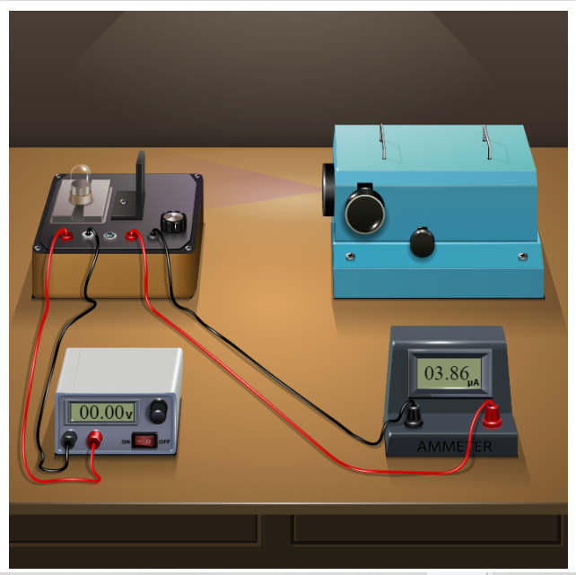

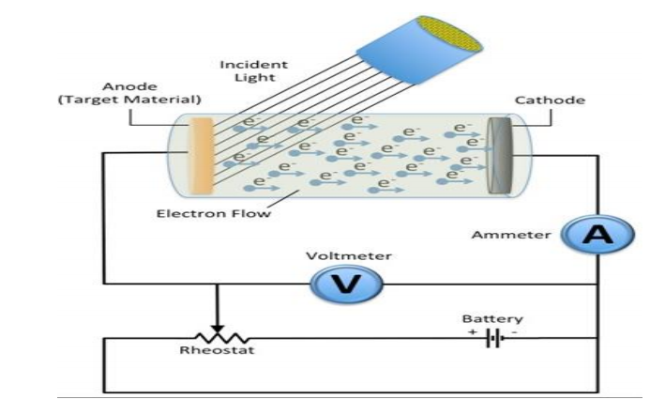

FORMULA-

W=hv0

K.E=h(v-vo)

OBSERVATIONS-

Material used - sodium

Area of plate - 0.2cm^2

Wavelength -150nm

Intensity -10w/m^2

|  |  |  |
| --- | --- | --- |
| **Sr.no** | Applied voltage(V) | Current (A) |
| 1. | -6.00V | 00.00A |
| 2. | -5.50V | 00.99A |
| 3. | -5.00V | 01.99A |
| 4. | -4.50V | 02.99A |
| 5. | -4.00V | 03.99A |
| 6. | -3.50V | 04.99A |
| 7. | -3.00V | 05.99A |
| 8. | -2.50V | 06.99A |
| 9. | -2.00V | 07.99A |
| 10. | -1.50V | 08.99A |

* Table for intensity – I2

|  |  |  |
| --- | --- | --- |
| **Sr.no** | Applied voltage(V) | Current(A) |
| 1. | -6.00V | 00.00A |
| 2. | -5.50V | 01.49A |
| 3. | -5.00V | 02.99A |
| 4. | -4.50V | 04.49A |
| 5. | -4.00V | 05.99A |
| 6. | -3.50V | 07.49A |
| 7. | -3.00V | 08.99A |
| 8. | -2.50V | 10.49A |
| 9. | -2.00V | 11.99A |
| 10. | -1.50V | 13.49A |

* Table for intensity – I3

|  |  |  |
| --- | --- | --- |
| **Sr.no** | Applied voltage(V) | Current (A) |
| 1. | -6.00V | 00.00A |
| 2. | -5.50V | 01.99A |
| 3. | -5.00V | 03.99A |
| 4. | -4.50V | 05.99A |
| 5. | -4.00V | 07.99A |
| 6. | -3.50V | 09.99A |
| 7. | -3.00V | 11.99A |
| 8. | -2.50V | 13.99A |
| 9. | -2.00V | 15.99A |
| 10. | -1.50V | 17.99A |

CALCULATIONS-

No Calculation.

PERCENTAGE ERROR-

No percentage error.

GRAPH (ATTACH IF ANY)-

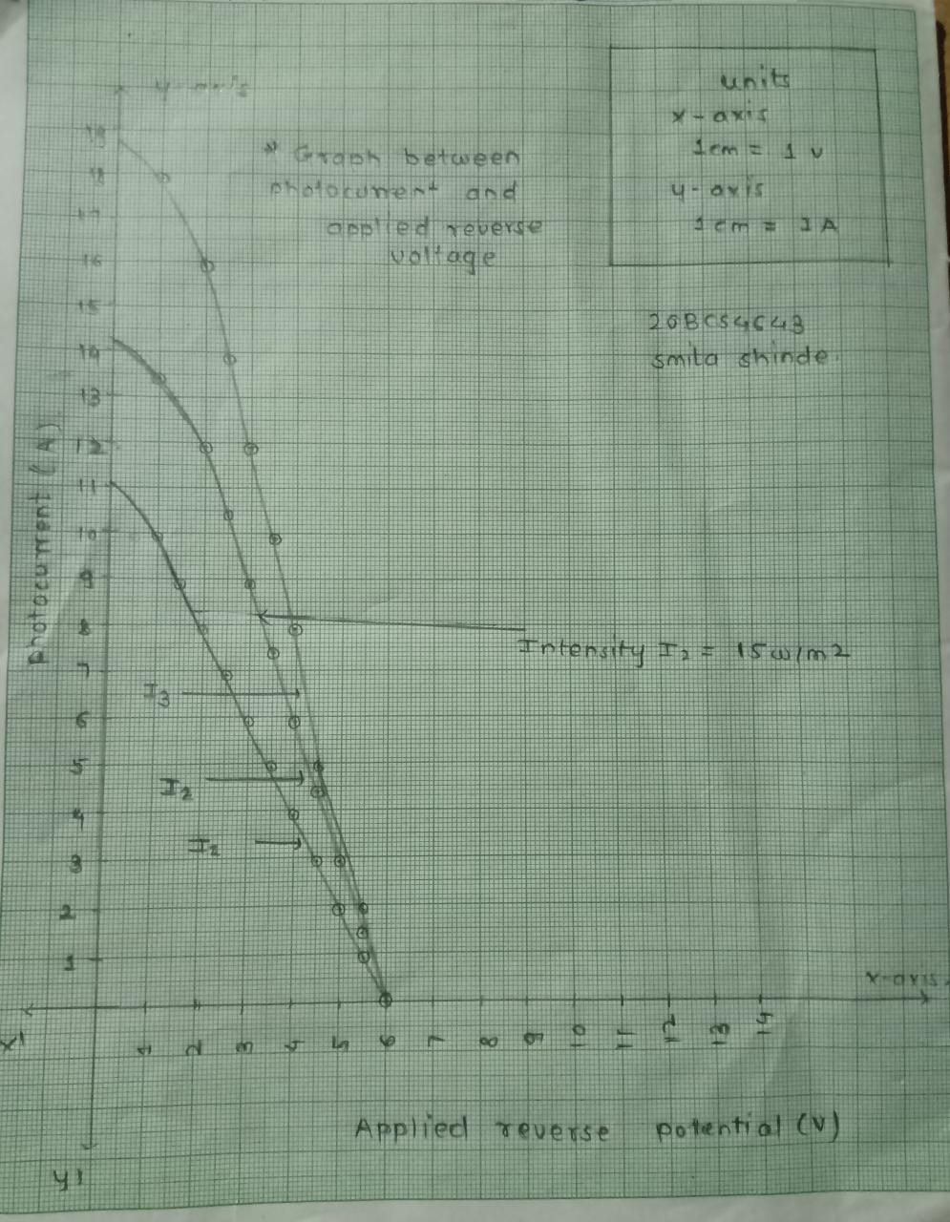

SOURCES OF ERROR-

No Source error.

RESULTS AND DISCUSSION-

Plot graph between photocurrent and applied reverse voltage.

The stopping potential = 6.0 volt

Conclusion:

The energy in light comes in small packets. Each of these packets is called a quantum of energy or a photon. From this representation it becomes clear that the low wavelength photons have high energy while the high wavelength photons have relatively low energy

LEARNING OUTCOMES

|  |
| --- |
| * It will provide the modest experience that allows students to develop and improve their experimental skills and develop ability to analyze data. |
| * Ability to demonstrate the practical skill on measurements and instrumentation techniques of some Physics experiments. Students will develop the ability to use appropriate physical concepts to obtain quantitative solutions to problems in physics. |
| * Students will demonstrate basic experimental skills by setting up laboratory equipment safely and efficiently, plan and carry out experimental procedures, and report verbally and in written language the results of the experiment. |
| * Students will develop skills by the practice of setting up and conducting an experiment with due regards to minimizing   measurement error. |

EVALUATION COLUMN (To be filled by concerned faculty only)

|  |  |  |  |
| --- | --- | --- | --- |
| **Sr. No.** | **Parameters** | **Maximum Marks** | **Marks Obtained** |
| 1. | Worksheet completion including writing learning objectives/Outcomes. (To be submitted at the end of the day) | 10 |  |
| 2. | Post Lab Quiz Result. | 5 |  |
| 3. | Student Engagement in Simulation/Demonstration/Performance and Controls/Pre-Lab Questions. | 5 |  |
| 4. | Total Marks | 20 |  |
| 5. | Teacher’s Signature (with date) |  | |